**UNIT-I**

An operating system is an essential component of a computer system. The primary objective of an operating system is to make computer system convenient and use and utilise computer between in an efficient manner. An operating system is a large collection of a Software, which manage resources of operating system Such as Memory processing ,File System and input/output devices, An operating system keeps track status of each resources and decide who have an central over computer resources, how long and when.

Or

What is an operating system?

An operating system is the most important software that runs on a computer. It manages the computer's memory and processes, as well as all of its software and hardware. It also allows you to communicate with the computer without knowing how to speak the computer's language. Without an operating system, a computer is useless.

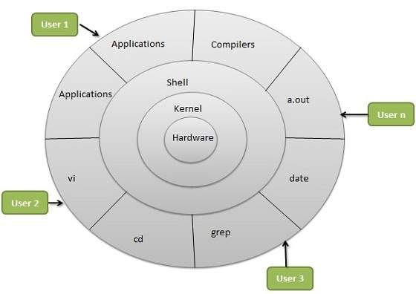

Operating system manage the computer between the control s the execution of the application program and provide the set of service to the user. An operating system work as an interface between user and Computer.

**Component of Computer system**

The application program required the operating system to carry out between related task such as printing report and storing the data on disk. The computer is the core of the system, But the H/w feen without an OS from the diagram, it is clear that OS directly controls computer h/w resources other program depend on facilities provided by by the operating system to gain access the computer system resources.

**Interaction With Operating System**

1. By means of OS cell in a Program
2. Directly by means of OS Commands

**1.System cell**- Provide the interface to a running program and the OS User program receive OS service through the set of system cells. These cells where available in assembly language instruction But Nowadays these features are supported through high level language, Like **C,PASCAL,** etc. as an example of how system, cells are used the following system cells will be generated by the OS .

* Promt massage for inputting two file name and reading it form terminal.
* Open source and destination file.
* Promt error massage in case the source file can’t be open because it is protected against access or destination file cannot be created because there is already a file with this name.
* Read the source file.
* Write into destination file.
* Close both file after the entire file is copied.

**2.Operting System Commands-** A part from system cells, user may interested with OS directly using OS command –

For exa- If you want to list files or sub directories in MS-Dos , you invoke directory command. In either case , the OS acts as an interface between users and the hardware of a computer system.

9./